A
Minor Project Report on
HealthSphere 360: A SmarthHealthcare Integration Platform Using Random Forest Algorithm
Submitted in the Partial Fulfillment of the
Requirements for the Award of the Degree of
BACHELOR OF TECHNOLOGY
in
Computer Science and Engineering
Submitted by
B PAVAN KUMAR 23881A05EV
N AKSHITH 23881A05GE
SARA FATIMA 23881A05GU
Under the esteemed guidance of
Mr Ganesh Deshmukh
Assistant Professor



DEPARTMENT OF COMPUTER SCIENCE AND ENGINEERING

2025-26


Department of Computer Science and Engineering

CERTIFICATE
This is to certify that the project titled HealthSphere 360: A SmarthHealthcare Integration Platform Using Random Forest Algorithm is carried out by
B PAVAN KUMAR 23881A05EV
N AKSHITH 23881A05GE
SARA FATIMA 23881A05GU

in partial fulfillment of the requirements for the award of the degree of Bachelor of Technology in Electronics and Communication Engineering during the year 2025-26.
Signature of the Supervisor | Signature of the HOD
Mr. Ganesh Deshmukh | Dr. Gagandeep Arora
Assistant Professor, CSE  Project Viva-voce held on 02/04/2026 | Professor and HOD, CSE
Internal Examiner | External Examiner

Kacharam (V), Shamshabad (M), Ranga Reddy (Dist.)–501218, Hyderabad, T.S.
Ph: 08413-253335, 253201, Fax: 08413-253482, www.vardhaman.org

Acknowledgements
The satisfaction that accompanies the successful completion of the task would be put incomplete without the mention of the people who made it possible, whose constant guidance and encouragement crown all the efforts with success.
We wish to express our deep sense of gratitude to Mr Ganesh Deshmukh, Assistant Professor, Department of Computer Science and Engineering, Vardhaman College of Engineering, for his able guidance and useful suggestions, which helped us in completing the project in time.
We are particularly thankful to Dr. Gagandeep Arora, the Head of the Department, Department of Computer Science and Engineering, his guidance, intense support and encouragement, which helped us to mould our project into a successful one.
We show gratitude to our honorable Principal Dr. J.V.R. Ravindra, for providing all facilities and support.
We avail this opportunity to express our deep sense of gratitude and heartful thanks to Dr. Teegala Vijender Reddy, Chairman and Sri Teegala Upender Reddy, Secretary of VCE, for providing a congenial atmosphere to complete this project successfully.
We also thank all the staff members of Computer Science and Engineering department for their valuable support and generous advice. Finally thanks to all our friends and family members for their continuous support and enthusiastic help.

B PAVAN KUMAR
N AKSHITH
SARA FATIMA

ABSTRACT
The 360 HealthSphere system is an advanced, intelligent, and fully integrated digital healthcare monitoring and disease prediction platform designed to transform conventional health assessment methods into a modern, automated, data driven ecosystem capable of providing real-time health insights, predictive diagnostics, and personalized recommendations. The system is developed as a comprehensive web-based solution that collects user health parameters such as age, weight, blood pressure, glucose levels, lifestyle habits, and symptom inputs and processes them through machine learning algorithms to predict potential health risks and diseases with high reliability. The platform integrates a Random Forest–based predictive model that analyzes multi-dimensional medical datasets and produces highly accurate classifications by combining outputs from multiple decision trees. The system provides multiple modules including health monitoring, BMI calculation, risk prediction, personalized health suggestions, and historical report tracking. Each module is designed to support preventive healthcare by identifying early warning signs of chronic conditions and lifestyle-related disorders. By integrating artificial intelligence, predictive analytics, and user-friendly interface design, the proposed system demonstrates how digital healthcare solutions can improve early diagnosis, reduce healthcare costs, assist medical professionals, and empower individuals to make informed decisions regarding their health. The platform ultimately contributes toward building a proactive healthcare ecosystem that focuses on prevention rather than treatment, thereby improving overall public health outcomes and reducing strain on healthcare infrastructure.

Keywords— Health Prediction, Machine Learning, Random Forest, Healthcare System, Disease Detection

Table of Contents
Title Page No.
Acknowledgements i
Abstract ii
List of Tables vi
List of Figures vii
Abbreviations vii

CHAPTER 1 Introduction . . . . . . . . . . . . . . . . . . . . . . . . 1
1.1 Introduction . . . . . . . . . . . . . . . . . . . . . . . . . . . . . . . 1
1.2 Background and Motivation . . . . . . . . . . . . . . . . . . . . . . 2
1.3 Objectives of the Project Work . . . . . . . . . . . . . . . . . . . 2
1.4 Organization of the Report . . . . . . . . . . . . . . . . . . . . . . 3
CHAPTER 2 Literature Survey . . . . . . . . . . . . . . . . . . . . . 4
2.1 Introduction . . . . . . . . . . . . . . . . . . . . . . . . . . . . . . . 4
2.2 Review of Prior Research . . . . . . . . . . . . . . . . . . . . . . . 4
2.3 Identified Research Gaps . . . . . . . . . . . . . . . . . . . . . . . 5
2.4 Summary . . . . . . . . . . . . . . . . . . . . . . . . . . . . . . . . 5
CHAPTER 3 System Analysis . . . . . . . . . . . . . . . . . . . . . . 6
3.1 Existing System . . . . . . . . . . . . . . . . . . . . . . . . . . . . 6
3.1.1 Disadvantages of Existing System . . . . . . . . . . . . . . 6
3.2 Proposed System . . . . . . . . . . . . . . . . . . . . . . . . . . . . 7
3.2.1 Advantages of Proposed System . . . . . . . . . . . . . . . 8
3.3 System Requirements . . . . . . . . . . . . . . . . . . . . . . . . . 8
3.3.1 Hardware Requirements . . . . . . . . . . . . . . . . . . . . 8
3.3.2 Software Requirements . . . . . . . . . . . . . . . . . . . . . 8
CHAPTER 4 System Design . . . . . . . . . . . . . . . . . . . . . . . 10
4.1 System Architecture . . . . . . . . . . . . . . . . . . . . . . . . . . 10
4.2 Data Flow Diagram . . . . . . . . . . . . . . . . . . . . . . . . . . 11
4.3 UML Diagrams . . . . . . . . . . . . . . . . . . . . . . . . . . . . . 11
4.3.1 Class Diagram . . . . . . . . . . . . . . . . . . . . . . . . . 11
4.3.2 Object Diagram . . . . . . . . . . . . . . . . . . . . . . . . 12
4.3. Collaboration Diagram . . . . . . . . . . . . . . . . . . . . . 12

4.3.4 Use Case Diagram . . . . . . . . . . . . . . . . . . . . . . . 13
4.3.5 Sequence Diagram . . . . . . . . . . . . . . . . . . . . . . . 13
4.3.6 Activity Diagram . . . . . . . . . . . . . . . . . . . . . . . . 14
4.3.7 Component Diagram . . . . . . . . . . . . . . . . . . . . . . 14
4.3.8 Deployment Diagram . . . . . . . . . . . . . . . . . . . . . . 15
CHAPTER 5 System Implementation . . . . . . . . . . . . . . . . . 16
5.1 Modules Description . . . . . . . . . . . . . . . . . . . . . . . . . . 16
5.1.1 User Input Module . . . . . . . . . . . . . . . . . . . . . . . 16
5.1.2 Data Preprocessing Module . . . . . . . . . . . . . . . . . . 16
5.1.3 Feature Extraction Module . . . . . . . . . . . . . . . . . . 16
5.1.4 Classification Module . . . . . . . . . . . . . . . . . . . . . 17
5.1.5 Result Storage Module . . . . . . . . . . . . . . . . . . . . 17
5.1.6 VisualizatOutput Module . . . . . . . . . . . . . . . . . . . 17
5.2 Technology Used . . . . . . . . . . . . . . . . . . . . . . . . . . . . 17
5.2.1 Programming Language . . . . . . . . . . . . . . . . . . . . 17
5.2.2 Libraries and Frameworks . . . . . . . . . . . . . . . . . . . 18
5.2.3 Development Environment . . . . . . . . . . . . . . . . . . . 18
5.2.4 Interface . . . . . . . . . . . . . . . . . . . . . . . . . . . . . 18
5.3 Algorithms used . . . . . . . . . . . . . . . . . . . . . . . . . . . . 18

CHAPTER 6 System Testing . . . . . . . . . . . . . . . . . . . . . . 21
6.1 Testing Methodology . . . . . . . . . . . . . . . . . . . . . . . . . . 21
6.2 Testing under Various Stages . . . . . . . . . . . . . . . . . . . . . 21
6.2.1 Input Stage Testing . . . . . . . . . . . . . . . . . . . . . . 21
6.2.2 Preprocessing Stage Testing . . . . . . . . . . . . . . . . . . 21
6.2.3 Feature Extraction Stage Testing . . . . . . . . . . . . . . . 22
6.2.4 Classification Stage Testing . . . . . . . . . . . . . . . . . . 22
6.2.5 Output Stage Testing . . . . . . . . . . . . . . . . . . . . . 22
6.3 Test Cases . . . . . . . . . . . . . . . . . . . . . . . . . . . . . . . . 22
CHAPTER 7 Results and Discussion . . . . . . . . . . . . . . . . . 24
7.1 Introduction . . . . . . . . . . . . . . . . . . . . . . . . . . . . . . . 24
7.2 Overview of Results . . . . . . . . . . . . . . . . . . . . . . . . . . 24
7.3 Result Screenshots . . . . . . . . . . . . . . . . . . . . . . . . . . . 25
7.4 Summary . . . . . . . . . . . . . . . . . . . . . . . . . . . . . . . . 26
CHAPTER 8 Conclusions and Future Scope . . . . . . . . . . . . . 27
8.1 Conclusions . . . . . . . . . . . . . . . . . . . . . . . . . . . . . . . 27
8.2 Future Scope of Work . . . . . . . . . . . . . . . . . . . . . . . . . 27
REFERENCES . . . . . . . . . . . . . . . . . . . . . . . . . . . . . . . . . 28

List of Tables
6.1 Test Cases for Cyberbullying Detection System . . . . . . . . . . 23
vi

List of Figures
4.1 System Architecture Diagram. . . . . . . . . . . . . . . . . . . . . 10
4.2 Data Flow Diagram . . . . . . . . . . . . . . . . . . . . . . . . . . 11
4.3 Class Diagram . . . . . . . . . . . . . . . . . . . . . . . . . . . . . 11
4.4 Object Diagram . . . . . . . . . . . . . . . . . . . . . . . . . . . . . 12
4.5 Collaboration Diagram . . . . . . . . . . . . . . . . . . . . . . . . . 12
4.6 Use Case Diagram . . . . . . . . . . . . . . . . . . . . . . . . . . . 13
4.7 Sequence Diagram . . . . . . . . . . . . . . . . . . . . . . . . . . . 13
4.8 Activity Diagram . . . . . . . . . . . . . . . . . . . . . . . . . . . . 14
4.9 Component Diagram . . . . . . . . . . . . . . . . . . . . . . . . . . 14
4.10 Deployment Diagram . . . . . . . . . . . . . . . . . . . . . . . . . . 15

Abbreviations
Abbreviation | Description
SVM | Support Vector Machine
NLP | Natural Language Processing

CHAPTER 1 INTRODUCTION

1.1 Introduction
360 HealthSphere is an advanced and integrated smart healthcare platform designed to improve the way people manage their health in daily life. In the traditional healthcare system, patients usually visit doctors only when they feel sick or face a health problem. This approach is known as the “break-fix” model, where treatment is provided only after illness occurs. However, this method does not focus on prevention or early detection of diseases. To overcome this limitation, 360 HealthSphere introduces a modern and intelligent solution that focuses on predictive and proactive healthcare.
The system uses the Random Forest machine learning algorithm, which is a powerful and reliable technique for prediction and decision-making. It processes large amounts of data such as user vitals (like heart rate, blood pressure, and sugar levels), lifestyle habits (such as diet, sleep, and physical activity), and medical history. By analyzing these factors together, the system can predict potential health issues and provide useful recommendations. 360 HealthSphere provides a 360-degree view of an individual’s health, meaning it looks at all aspects of a person’s well-being rather than focusing on a single problem. It connects clinical healthcare (doctor visits, medical reports) with home-based wellness (daily habits and monitoring). This integration ensures continuous care and better health management. Overall, 360 HealthSphere aims to create a smarter healthcare ecosystem where prevention is prioritized, risks are minimized, and individuals are empowered to take control of their health in a simple and effective way.

1.2 Problem Statement

In the current healthcare system, most medical services are reactive, where patients seek treatment only after symptoms become severe, leading to delayed diagnosis and increased healthcare costs. Chronic diseases such as diabetes and hypertension often develop silently, making early detection difficult without continuous monitoring. Additionally, there is a lack of integration between clinical visits and daily health tracking, which results in incomplete health information for both patients and doctors. Access to quality healthcare is also limited in rural and remote areas, creating inequality in health management. Although large amounts of health data are generated through wearable devices and manual inputs, it is not effectively utilized for prediction and prevention. Therefore, there is a need for an intelligent system that can continuously monitor, analyze, and predict potential health risks, providing timely insights and recommendations to improve overall healthcare outcomes.

1.3 Background and Motivation

The motivation for developing 360 HealthSphere arises from the increasing global burden of chronic diseases such as diabetes and hypertension, which require continuous monitoring and early detection. Traditional healthcare systems are mostly reactive in nature, where treatment is provided only after symptoms become severe, making it costly and less effective. Additionally, access to quality healthcare remains limited, especially for people living in rural and remote areas. With the rapid growth of digital technology, large amounts of health-related data are now generated through wearable devices and manual inputs. This project is positioned in the field of Digital Health and Predictive Analytics, aiming to make use of this data to identify early warning signs and silent symptoms before they develop into serious health conditions. By doing so, 360 HealthSphere seeks to promote preventive healthcare, reduce medical costs, and improve accessibility to health monitoring for a wider population.

1.4 Objective

The main objective of 360 HealthSphere is to develop an intelligent and user-friendly healthcare platform that supports predictive and preventive care. The system aims to collect and analyze user health data such as vitals, lifestyle habits, and medical history to provide accurate health predictions using the Random Forest algorithm. It also focuses on early detection of potential diseases like diabetes and hypertension, enabling users to take timely action. Another objective is to provide personalized health recommendations, alerts, and insights to improve overall well-being. The platform is designed to bridge the gap between clinical care and home monitoring, ensuring continuous health tracking. Additionally, it aims to make healthcare more accessible and affordable, especially for people in rural areas, while assisting healthcare professionals with reliable data for better decision-making.

1.5 Organization of the Report
This report is structured into seven chapters for clarity and systematic presentation of the project.
Chapter 1: Introduction – Presents the background, motivation, objectives, and overview of the project.
Chapter 2: Literature Review – Discusses existing research, related work, and current solutions in the domain.
Chapter 3: System Analysis – Explains system requirements, problem analysis, and the proposed system.
Chapter 4: System Design – Describes the architecture, design approach, and UML diagrams.
Chapter 5: Implementation – Details the development process and the use of the Random Forest algorithm.
Chapter 6: Testing – Covers testing methods, results, and system validation.
Chapter 7: Conclusion – Summarizes the project outcomes and suggests future enhancements.
CHAPTER 2: LITERATURE SURVEY

2.1 Introduction
This chapter focuses on the study of existing technologies and research developments related to digital healthcare systems and predictive analytics. Over the years, healthcare has evolved from paper-based records to advanced Electronic Health Records (EHR), which allow efficient storage, retrieval, and management of patient data. With the advancement of technology, Artificial Intelligence (AI) has been increasingly integrated into healthcare systems to assist in diagnosis, prediction, and decision-making. AI-based tools help in analyzing large volumes of medical data quickly and accurately, improving the overall quality of healthcare services. This chapter highlights how these technologies have contributed to modern healthcare and sets the foundation for developing more advanced and intelligent systems like 360 HealthSphere.

2.2 Review of Prior Research
Various research studies have been conducted in the field of disease prediction using machine learning techniques. Algorithms such as Support Vector Machine (SVM) and Logistic Regression have been widely used for predicting diseases based on patient data. These models perform well for structured and clean datasets; however, they often face challenges when dealing with real-world data, which includes noise, missing values, and complex relationships between variables. Lifestyle data, such as eating habits, sleep patterns, and physical activity, is usually unstructured and highly variable, making it difficult for traditional models to produce accurate results. Recent studies have shown that ensemble learning methods, particularly Random Forest, provide better performance in such cases. Random Forest works by combining multiple decision trees, which improves prediction accuracy and reduces the chances of overfitting. It is especially effective in handling non-linear relationships and large datasets commonly found in healthcare, making it a suitable choice for predictive health systems.

2.3 Identified Research Gaps
Despite the advancements in digital healthcare and predictive analytics, several limitations still exist in current systems. Most available health applications and devices operate in isolation, focusing only on specific parameters such as step count, heart rate, or calorie intake, without integrating them with a user’s medical history or clinical data. This lack of integration results in incomplete analysis and limits the ability to predict future health risks accurately. There is also a lack of platforms that combine high prediction accuracy with a simple, user-friendly, and human-centered interface. Therefore, there is a need for a comprehensive system that integrates multiple data sources, provides accurate predictions, and offers an easy-to-use interface to support both patients and healthcare professionals.

2.4 Summary
The literature survey for 360 HealthSphere shows that many existing healthcare systems use machine learning algorithms such as Decision Trees, SVM, and Logistic Regression for disease prediction. It also highlights the growing use of digital health technologies like wearable devices and mobile applications for continuous health monitoring. However, most systems work independently and do not combine lifestyle data with medical history, which limits their ability to provide accurate predictions. Many applications also lack real-time analysis and user-friendly interfaces. Based on these findings, 360 HealthSphere is designed to overcome these limitations by integrating multiple health data sources, using the Random Forest algorithm for higher prediction accuracy, and providing a simple and effective platform for both users and healthcare professionals.

CHAPTER 3: SYSTEM ANALYSIS
3.1 Existing System
The existing healthcare systems mainly depend on manual tracking methods or single-purpose applications that focus on only one aspect of health, such as step counting, calorie tracking, or blood sugar logging. These applications work independently and do not provide a complete picture of a person’s health. In most cases, the collected data is stored locally and is not shared with healthcare professionals in real-time, which limits its usefulness for medical analysis. Patients are required to visit hospitals frequently for checkups, and doctors rely on limited or outdated information during diagnosis. This leads to inefficiency in treatment and increases the chances of missing early symptoms of chronic diseases. Disadvantages of the existing system include fragmented and unorganized data, lack of integration between different health parameters, delayed detection of diseases, limited use of advanced analytics, and high dependency on physical hospital visits, which can be time-consuming and costly, especially for rural populations.

3.1.1 Disadvantages of Existing System
- Fragmented and unorganized health data due to use of multiple single-purpose applications
- Lack of integration between lifestyle data, medical history, and real-time vitals
- Reactive approach that focuses on treatment after symptoms appear instead of prevention
- No real-time data sharing with doctors, leading to delayed diagnosis
- Difficulty in handling large and complex health data accurately
- Limited use of advanced machine learning techniques for prediction
- User interfaces are often complex and not user-friendly
- High dependency on physical hospital visits, increasing time and cost
- Poor accessibility for people in rural and remote areas
- Inability to provide continuous monitoring and early risk detection

3.2 Proposed System
The proposed system, 360 HealthSphere, is an integrated and intelligent healthcare platform designed to provide predictive and preventive healthcare services. It collects health-related data from users through manual inputs and wearable devices, ensuring continuous monitoring of vital parameters such as heart rate, blood pressure, and lifestyle habits. The system uses the Random Forest machine learning algorithm to analyze this data and identify patterns that help in predicting potential health risks at an early stage. All the collected data is stored in a centralized database, which allows easy access and efficient management of information. The platform generates real-time alerts, health reports, and personalized recommendations to help users maintain better health. It also enables data sharing with healthcare professionals, supporting accurate diagnosis and improved decision-making. With a user-friendly interface, the system is easy to use for all types of users. Overall, 360 HealthSphere reduces the need for frequent hospital visits and promotes accessible, proactive, and efficient healthcare management.

3.2.1 Advantages of Proposed System
• Provides early detection of diseases through predictive analysis using the Random Forest algorithm
• Integrates multiple health parameters such as vitals, lifestyle habits, and medical history
• Offers real-time monitoring and continuous health tracking
• Generates personalized health reports, alerts, and recommendations
• Centralized data storage for easy access and better data management
• Enables data sharing with doctors for improved diagnosis and treatment
• User-friendly interface suitable for all types of users

3.3 System Requirements
3.3.1 Hardware Requirements
• Processor: Intel i3 or higher
• RAM: Minimum 4 GB (8 GB recommended)
• Storage: 500 GB Hard Disk or above
• System Type: Laptop or Desktop
• Internet: Stable high-speed internet connection
• Devices: Wearable sensors (optional)
3.3.2 Software Requirements
• Operating System: Windows, Linux, or macOS
• Programming Language: Python
• Libraries:
– NumPy
– Pandas
– Scikit-learn
– NLTK / SpaCy
– Matplotlib / Seaborn
• Framework: Flask / Django / Streamlit
• Database: MySQL / MongoDB
• IDE: Jupyter Notebook or Visual Studio Code

CHAPTER 4: SYSTEM DESIGN

4.1 System Architecture
The 360 HealthSphere system is designed using a three-tier architecture, which ensures better performance, scalability, and maintainability. The first layer is the User Interface layer, which acts as the front-end of the system and allows users to interact with the application through web or mobile platforms. In this layer, users can enter health data, view reports, and receive alerts in a simple and user-friendly manner. The second layer is the Application Server layer, also known as the Machine Learning Engine, where all the core processing takes place. This layer is responsible for handling user requests, processing the input data, and applying the Random Forest algorithm to analyze patterns and predict health risks. It acts as a bridge between the user interface and the database. The third layer is the Database layer, where all user data, medical history, and prediction results are securely stored. Databases such as MySQL or MongoDB are used to manage and retrieve data efficiently. This three-tier architecture helps in separating concerns, improving system security, and making the application easier to update and maintain.

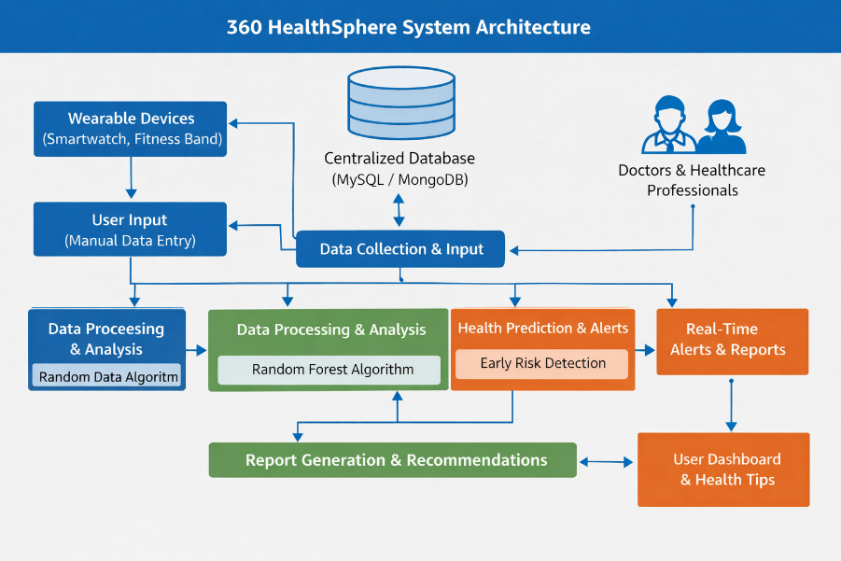
Figure 4.1: System Architecture Diagram.
The System Architecture Diagram shows how 360 HealthSphere works in three layers: User Interface, Application Server, and Database. The user enters health data through the interface, which is processed by the server using the Random Forest algorithm. The data is stored in the database, and the system generates reports and alerts that can be viewed by users and doctors.

4.2 Data Flow Diagram
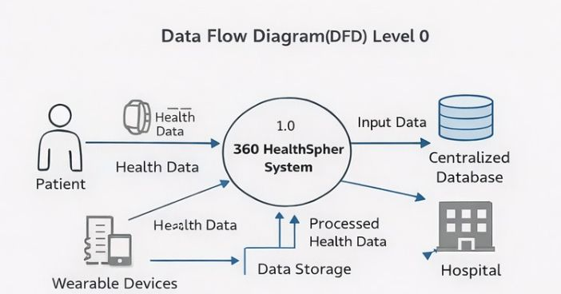
Figure 4.2: Data Flow Diagram

The Data Flow Diagram shows how data moves in the 360 HealthSphere system. The user enters health data, which is collected and processed by the system. The data is then stored in the database and analyzed to generate reports and alerts, which are shared with the user and doctor.

4.3 UML Diagrams
The UML diagrams in 360 HealthSphere help in understanding the structure and working of the system clearly. The Class Diagram shows the main classes such as User, Health Data, Report, and Doctor, along with their attributes and relationships. The Object Diagram represents real-time instances of these classes and how they are connected at a particular moment. The Collaboration Diagram explains how different components like user, web application, database, and machine learning model interact with each other through message passing.

4.3.1 Class Diagram
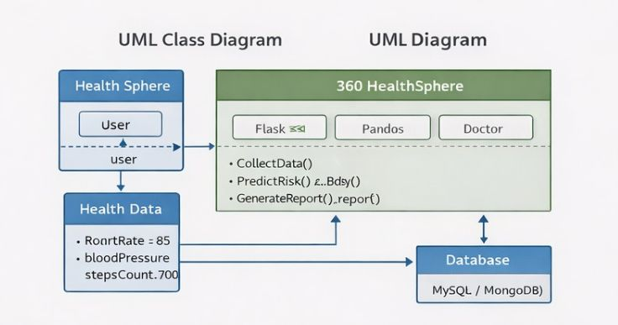

Figure 4.3: Class Diagram

The Class Diagram represents the structure of the 360 HealthSphere system by showing different classes such as User, Health Data, Doctor, and Report along with their attributes and relationships. It explains how data is organized and how different parts of the system are connected

.4.3.2 Object Diagram

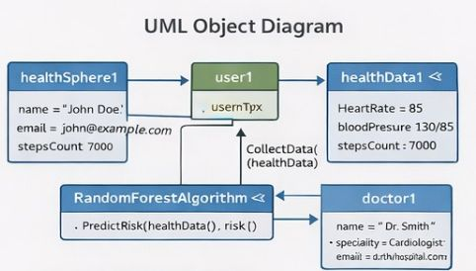

Figure 4.4: Object Diagram

The Object Diagram shows the real-time instances of the classes defined in the class diagram. It represents how objects like a specific user, their health data, and reports interact with each other at a particular moment.

4.3.3 Collaboration Diagram

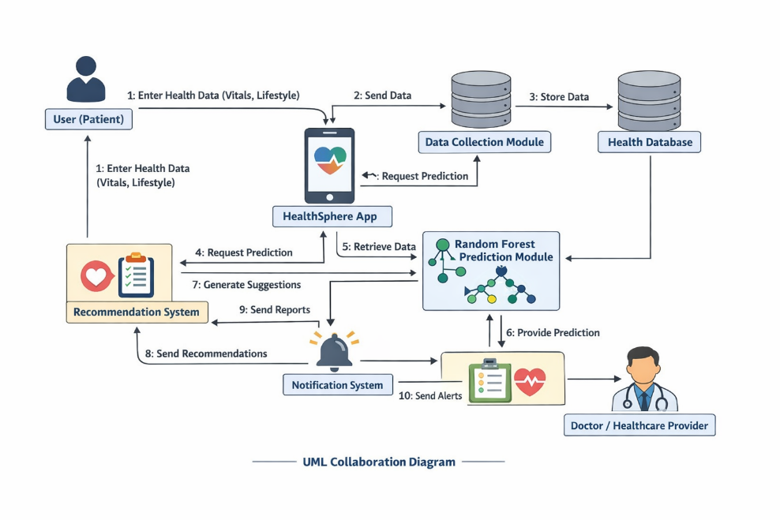
Figure 4.5: Collaboration Diagram

The Collaboration Diagram illustrates how different components of the system communicate with each other. It shows the interaction between user, web application, database, and machine learning model through message passing to complete system operations.

4.3.4 Use Case Diagram
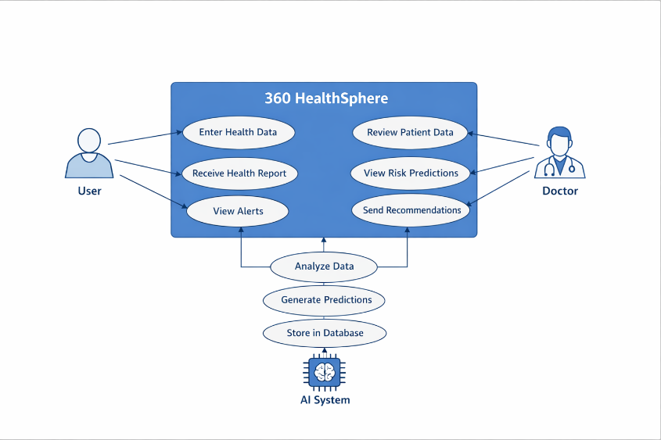
Figure 4.6: Use Case Diagram

The Use Case Diagram describes how users and doctors interact with the system functionalities such as entering data, viewing reports, and receiving alerts. The Sequence Diagram shows the step-by-step flow of operations from data input to prediction and result generation. The Activity Diagram represents the overall workflow of the system, including data entry, processing, decision-making, and output generation.

4.3.5 Sequence Diagram

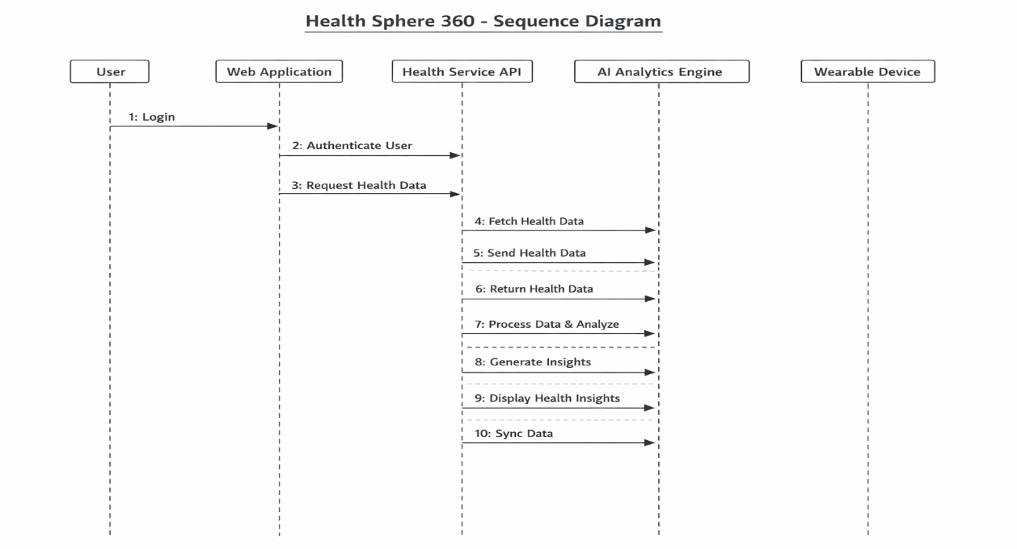
Figure 4.7: Sequence Diagram

The Sequence Diagram shows the step-by-step flow of interactions between different components over time. It explains how the user sends a request, how the system processes it through the web application, database, and machine learning model, and finally how the response is returned to the user in an organized manner

4.3.6 Activity Diagram
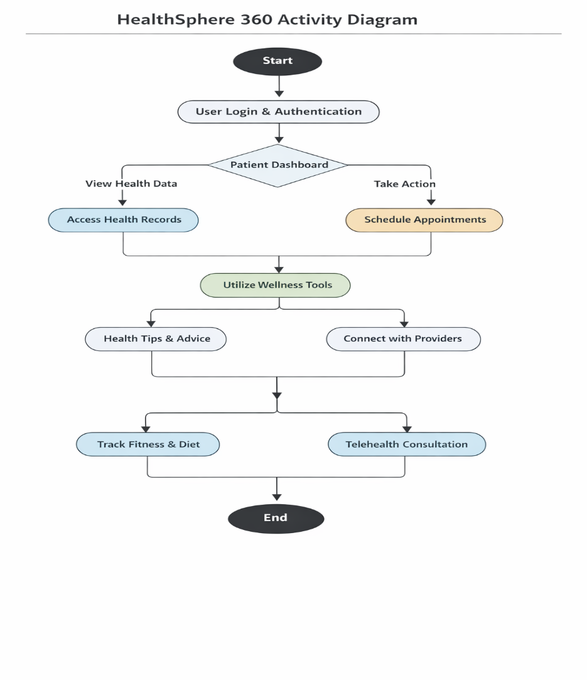
Figure 4.8: Activity Diagram

4.3.7 Component Diagram
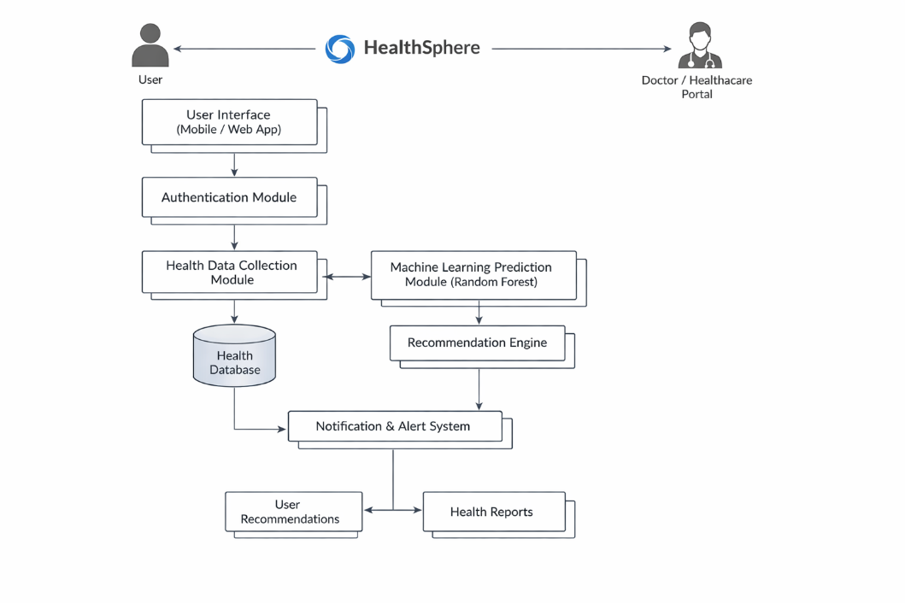
Figure 4.9: Component Diagram

4.3.8 Deployment Diagram
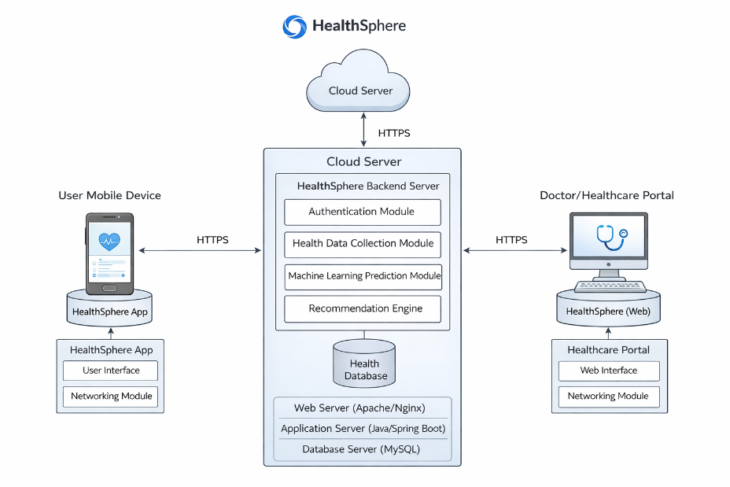
Figure 4.10: Deployment Diagram

CHAPTER 5: SYSTEM IMPLEMENTATION

5.1 Modules Description
The HealthSphere 360 system is designed as a collection of interconnected modules that work together to process and analyze healthcare data efficiently. It begins with the User Input Module, where patients, doctors, or admins enter data, which is then cleaned and organized by the Data Preprocessing Module to ensure accuracy and consistency. Important features are identified by the Feature Extraction Module, and the Classification Module applies machine learning algorithms to categorize or predict health outcomes. The processed results are securely stored in the Result Storage Module, while the Visualization Output Module presents them in charts, graphs, or tables for easy understanding. Together, these modules ensure smooth data flow, accurate analysis, and clear insights for users.

5.1.1 User Input Module
The User Input Module in HealthSphere 360 is responsible for collecting data from the system’s users, such as patients, doctors, or administrators. It allows users to enter information like personal details, symptoms, medical history, or appointment requests. This module ensures that the data entered is complete, accurate, and in the correct format before it is sent to the next stage of the system for processing. It acts as the first point of interaction between the user and the system, making it essential for smooth and reliable operation.

5.1.2 Data Preprocessing Module
In this module, the input text is cleaned and normalized. It includes operations such as:
- Conversion to lowercase
- Removal of special characters, URLs, and stopwords
- Tokenization and stemming/lemmatization
This step ensures that the text is in a suitable format for feature extraction.

5.1.3 Feature Extraction Module
This module transforms the cleaned text into numerical features that can be used by machine learning models. Techniques used include:
- TF-IDF (Term Frequency–Inverse Document Frequency)
- Bag of Words (BoW)
These features represent the importance of words in the text.

5.1.4 Classification Module
The Classification Module in HealthSphere 360 uses the Random Forest algorithm to analyze processed data and make predictions or classifications. Random Forest works by creating multiple decision trees and combining their results to produce more accurate and reliable outcomes. This module examines the features extracted from user data to predict health-related outcomes, such as disease risk or recommended actions. By using Random Forest, the system ensures high accuracy, reduces errors, and provides dependable insights to help users make informed decisions.

5.1.5 Result Storage Module
The Result Storage Module in HealthSphere 360 is responsible for securely saving the processed data and analysis results generated by the system. After the classification module predicts outcomes, this module stores the information in a structured database so it can be easily retrieved later for reference, reporting, or further analysis. It ensures that all user data and results are kept safe, organized, and accessible, providing a reliable way to track patient health and system performance over time.

5.1.6 Visualization Output Module
The Visualization Output Module presents the system’s results in an easy-to-understand visual format, such as charts, graphs, and tables. It helps users quickly interpret insights from the data, track patient health trends, and make informed decisions. This module ensures that complex information is displayed clearly and effectively for both patients and healthcare professionals.

5.2 Technology Used
The system uses modern technologies to implement healthcare analytics efficiently. It combines a robust programming language, specialized libraries and frameworks, a supportive development environment, and a user-friendly interface. These technologies work together to ensure accurate data processing, analysis, and visualization.

5.2.1 Programming Language
• Python is used due to its simplicity and strong support for machine learning and NLP.

5.2.2 Libraries and Frameworks
- NumPy and Pandas – for data manipulation and analysis
- Scikit-learn – for machine learning models (SVM)
- NLTK / spaCy – for text preprocessing and NLP tasks
- Matplotlib / Seaborn – for data visualization
5.2.3 Development Environment
- Jupyter Notebook / VS Code – for coding and experimentation
5.2.4 Interface
The system provides a user-friendly graphical interface (GUI) that allows patients, doctors, and admins to interact easily. The interface enables smooth data input, access to results, and visualization, making the system accessible even to users with minimal technical knowledge.

5.3 Algorithms used
HealthSphere 360 uses the Random Forest algorithm for classification, which analyzes the processed data to predict health outcomes. Random Forest works by creating multiple decision trees and combining their results to improve accuracy and reliability. Additionally, NLP preprocessing techniques like tokenization, stopword removal, and stemming are applied to prepare textual data for analysis. Together, these methods ensure the system delivers precise, dependable, and insightful health predictions.

5.4 Coding
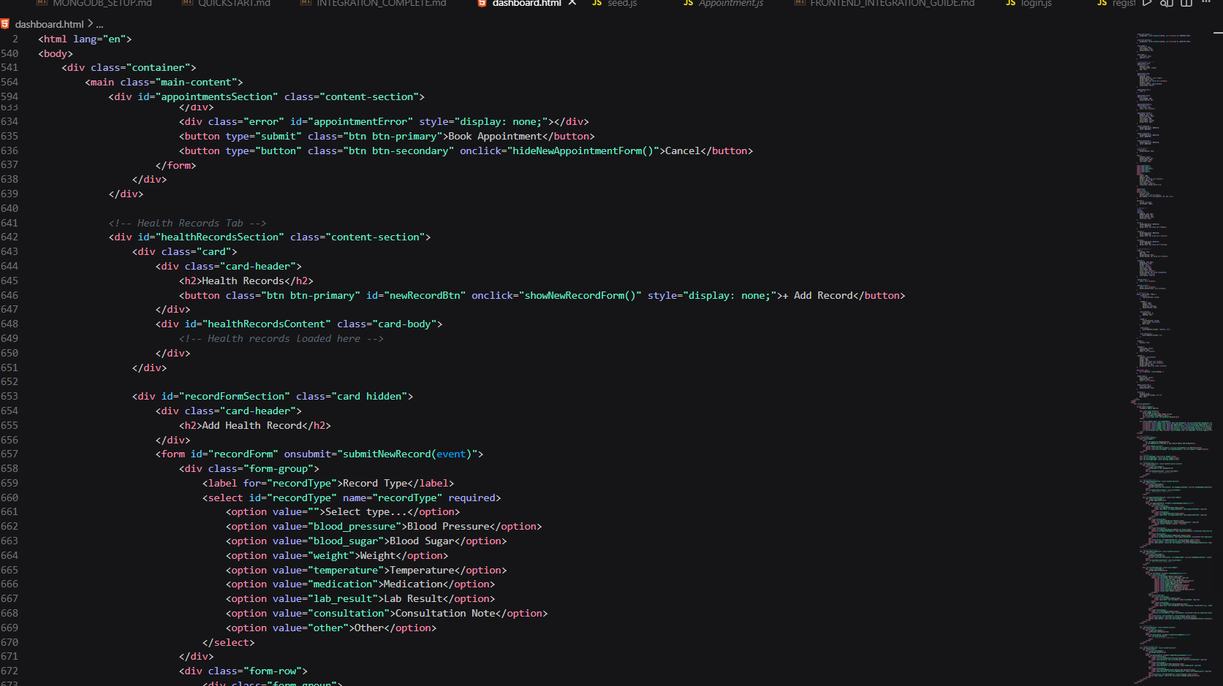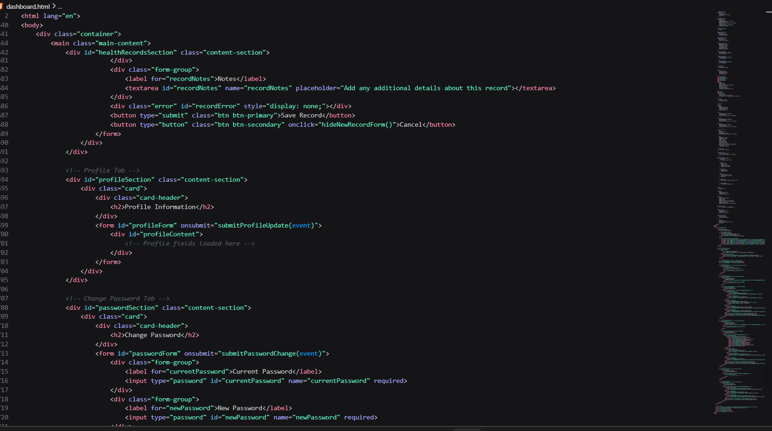

CHAPTER 6: SYSTEM TESTING

6.1 Testing Methodology
The Testing Methodology defines how the HealthSphere 360 system is evaluated to ensure it works correctly and meets requirements. It involves systematic checking of each module and functionality, identifying errors or issues, and validating that the system performs accurately under different conditions. Testing ensures reliability, efficiency, and robustness of the system before deployment.The following testing methodologies are used:
Unit Testing: Each module such as preprocessing, feature extraction, and classification is tested independently.
Integration Testing: Ensures that all modules work together seamlessly.
System Testing: Validates the complete system performance using real-time input data.
Validation Testing: Checks whether the system meets user requirements and produces accurate results.

6.2 Testing under Various Stages
Testing is performed at different stages of the system to ensure every part functions correctly. Each stage focuses on the specific tasks performed in that part of the workflow, from input collection to result visualization. This staged testing helps detect and fix issues early in the system.

6.2.1 Input Stage Testing
This stage tests the User Input Module to ensure that data entered by patients, doctors, or admins is captured accurately. It checks for proper formatting, completeness, and validation of input fields, and ensures that invalid or missing data is handled correctly.

6.2.2 Preprocessing Stage Testing
In the Data Preprocessing Module, testing verifies that raw data is cleaned, organized, and prepared correctly. It ensures missing values, duplicates, and irrelevant information are handled properly so that the data is accurate and consistent for further analysis.

6.2.3 Feature Extraction Stage Testing
Testing the Feature Extraction Module ensures that important features are correctly identified from the processed data. It validates that only relevant attributes are extracted and unnecessary data is ignored, which is crucial for accurate classification later.

6.2.4 Classification Stage Testing
This stage tests the Classification Module using Random Forest to ensure predictions and classifications are accurate. It checks the correctness of outputs, evaluates the model’s performance, and ensures the system reliably predicts health outcomes based on the extracted features.

6.2.5 Output Stage Testing
The output is validated to ensure that:
- Results are displayed correctly
- Messages are labeled accurately
- Data is stored properly in the database

6.3 Test Cases
The following test cases were used to validate the system
S.No | Test Case | Expected Output | Result
1 | Input: Patient details (Name, Age, Symptoms) | Data successfully stored in database | Pass
2 | Input: Appointment request | Appointment scheduled and confirmed | Pass
3 | Input: Empty or missing fields | Error message displayed prompting correct input | Pass
4 | Input:Special characters in patient name or notes | Handled properly without crash | Pass
5 | Input: Health data for classification | Classified correctly by Random Forest algorithm | Pass
6 | Input: Request to view visual report | Graphs or charts displayed correctly | Pass
Table 6.1: Test Cases for HealthSphere 360 System
CHAPTER 7: RESULT AND DISCUSSION

7.1 Introduction
This section introduces the outcomes of the HealthSphere 360 system after implementation and testing. It explains the purpose of analyzing results, evaluating system performance, and understanding how the system meets its objectives, such as accurate health prediction and effective data visualization.

7.2 Overview of Results
The overview presents a summary of the system’s performance including: successful data processing
- feature extraction
- classification using Random Forest
- accurate visualization of results.
It highlights how the system handles various inputs, maintains reliability, and achieves the expected outputs in different scenarios.

7.3 Result Screenshots
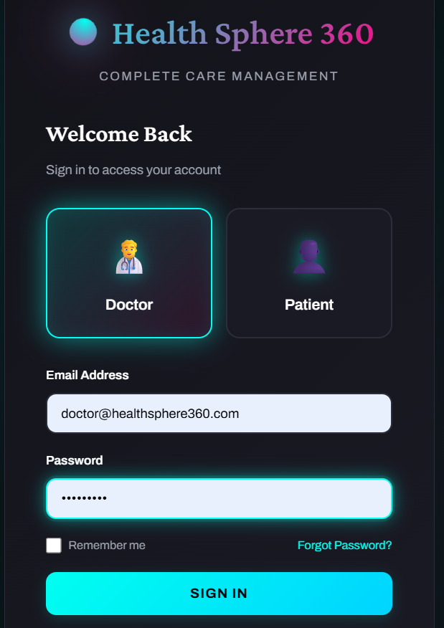

Figure 7.1: Register Homepage
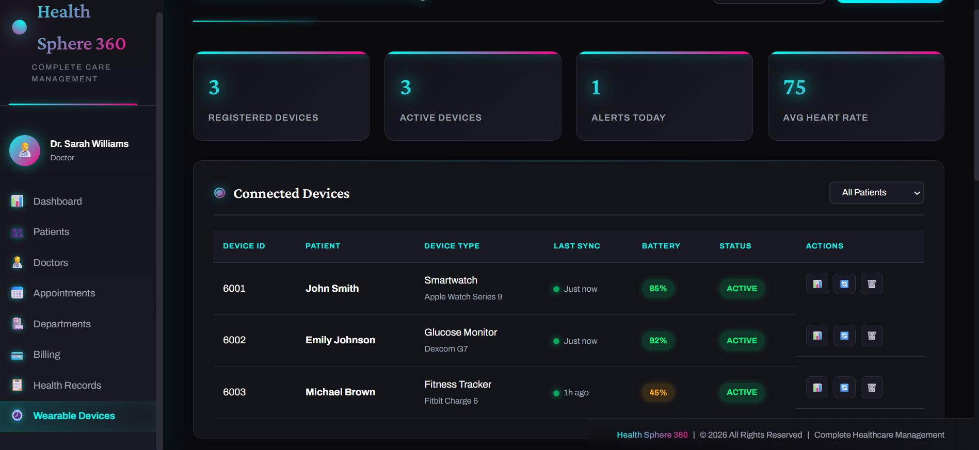

Figure 7.2: Wearble devices Dashboard
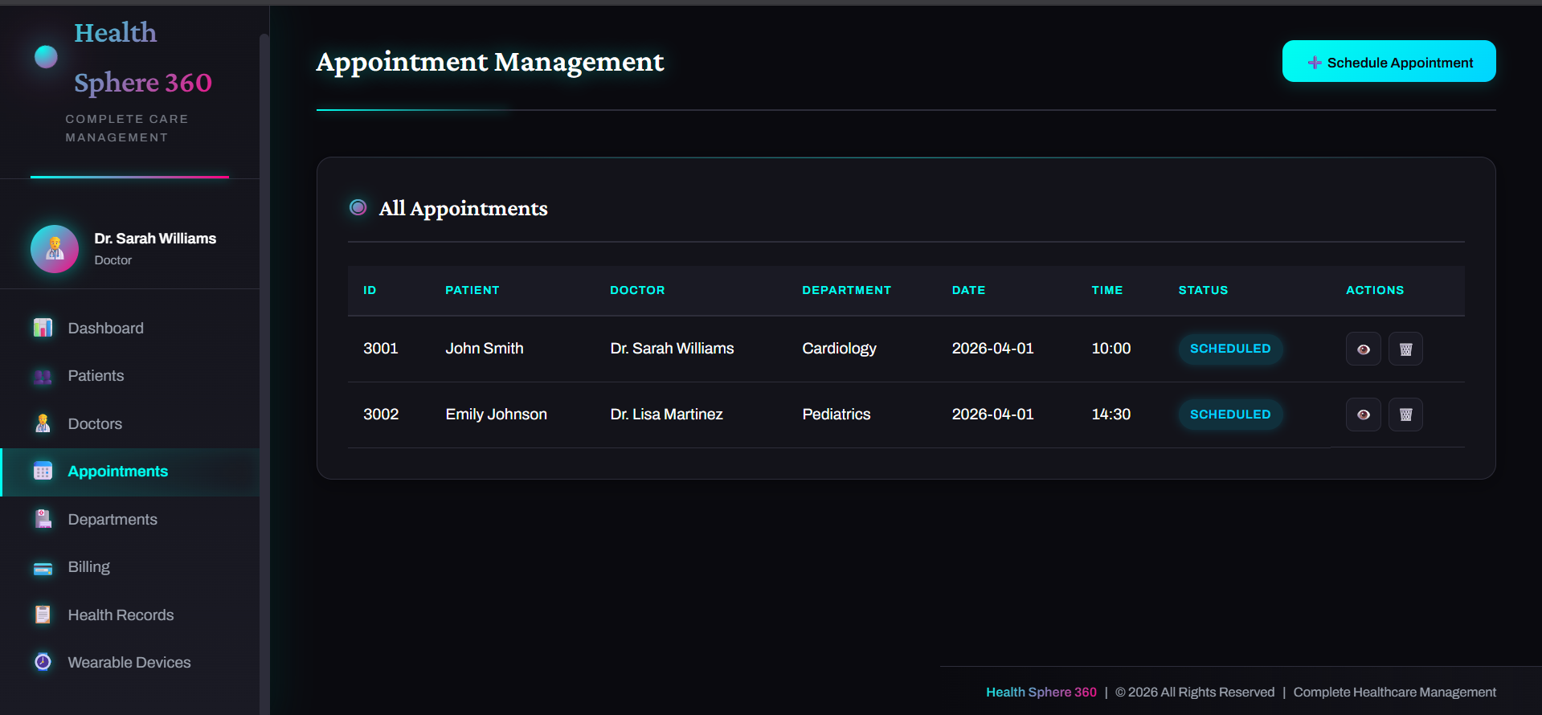
Figure 7.3: Appointments Dashboard

7.4 Summary
HealthSphere 360 is a comprehensive digital health management system designed to monitor, manage, and improve the overall health and well-being of individuals through a centralized platform. The system enables users to track their health parameters, maintain medical records, receive health alerts, and access healthcare services efficiently.
The project focuses on providing a 360-degree view of personal health, allowing users to monitor vital signs, schedule appointments, store prescriptions, and receive personalized health recommendations. It integrates modern technologies such as web applications, databases, and data analytics to ensure accurate health tracking and secure data management.
This system is especially useful for individuals who want to maintain regular health monitoring, patients with chronic diseases, and healthcare providers who need quick access to patient information. By digitizing health records and automating reminders, HealthSphere 360 helps reduce medical errors, improve treatment efficiency, and promote preventive healthcare.

CHAPTER 8: CONCLUSION AND FUTURE SCOPE

8.1 Conclusions
360 HealthSphere successfully demonstrates the potential of integrating modern digital technologies with healthcare systems to shift from a reactive approach to a predictive and preventive model. The platform is designed to provide a comprehensive and continuous view of an individual’s health by combining clinical data, real-time vitals, lifestyle habits, and medical history into a single intelligent system.
By utilizing the Random Forest machine learning algorithm, the system effectively analyzes complex health data and identifies potential risks such as diabetes and hypertension at an early stage. This enables timely intervention, reducing the chances of severe health complications and lowering overall healthcare costs. The system also empowers users by providing personalized health recommendations, alerts, and insights, encouraging them to take proactive steps toward maintaining their well-being.
Overall, the project highlights how data-driven decision-making and intelligent systems can transform healthcare into a more efficient, accessible, and user-centered ecosystem. 360 HealthSphere not only improves individual health management but also contributes to the broader goal of creating a smarter and more sustainable healthcare system.

8.2 Future Scope of Work
360 HealthSphere platform has significant potential for further enhancement and expansion in the future. One of the major areas of improvement is the integration of more advanced machine learning and deep learning techniques. Algorithms such as neural networks and real-time predictive models can be incorporated to improve accuracy and enable more complex health predictions. The system can also be expanded to include a wider range of diseases beyond diabetes and hypertension, such as heart diseases, mental health conditions, and respiratory disorders. By incorporating multi-disease prediction capabilities, the platform can become a more comprehensive healthcare solution.
Another important future enhancement is the integration of Internet of Things (IoT) devices. Advanced wearable sensors and smart health devices can provide real-time, continuous data, making predictions more accurate and reliable. Additionally, incorporating features such as voice assistants and chatbot-based health support can improve user interaction and accessibility.
.
In the future, 360 HealthSphere can also be connected with government healthcare systems and hospitals to create a unified digital health ecosystem. This would allow better data sharing, improved disease monitoring at a population level, and more effective healthcare planning.
In conclusion, with continuous advancements and improvements, 360 HealthSphere has the potential to evolve into a fully intelligent, scalable, and globally accessible healthcare platform that plays a crucial role in promoting preventive healthcare and improving the quality of life.

REFERENCES
[1] Journal — Springer (2025) S. Abedian, “Streamlining wearable data integration for EHDS,” Frontiers in Digital Health, vol. 2, 2025
[2] Journal — Springer / Journal of Cloud Computing (2025) Y. Y. Ghadi et al., “Integration of wearable technology and artificial intelligence in digital health for remote patient care,” Journal of Cloud Computing, vol. 14, 2025
[3] Journal — Springer (2025) L. Xi, C. Li, M. S. Anari et al., “Integrating wearable health devices with AI and edge computing for personalized rehabilitation,” Journal of Cloud Computing, vol. 14, 2025
[4] Journal — JMIR (2025) S. S. Mak, R. L. Kinney, A. L. Bailey et al., “Integrating consumer-grade wearable devices and patient generated health data into clinical care,” Journal of General Internal Medicine, vol. 40, 2025
[5] Journal — Elsevier (2025) A. Jain, “AI-driven wearable health devices with health-aware systems,” Journal of Biomedical Informatics, 2025.
[6] Journal — Elsevier (2025) F. N. Al-Wesabi et al., “An IoT-driven approach to remote patient health monitoring and management,” Alexandria Engineering Journal, vol. 87, 2025.
[7] Journal — MDPI (2025) S. Kajornkasirat et al., “Integrating AI-driven predictive analytics in wearable IoT systems for infectious disease monitoring,” Applied Sciences, vol. 15, no. 8, 2025
[8] Journal — MDPI (2025) G. Huang, “AI-driven wearable bioelectronics in digital healthcare,” Biosensors, vol. 15, no. 7, 2025.
[9] Journal — MDPI (2024) H. Alasmary et al., “ScalableDigitalHealth (SDH): An IoT-based remote patient monitoring framework,” Sensors, vol. 24, no. 4, 2024.
[10] Journal — Nature Scientific Reports (2024) S. K. Mathivanan et al., “A comprehensive health assessment approach using ensemble deep learning for remote patient monitoring IoT applications,” Scientific Reports, vol. 14, 2024
Shukla and Mansuri, “Cloud-integrated digital health platform for wear able analytics and patient data management,” 2024.
[12] Pathak and Kumar, “Interoperability challenges in digital healthcare platforms and unified health data systems,” 2023.
[13] Rodrigues et al., “Unified IoT and machine learning based model for healthcare data integration,” 2024.
[14] Wang, “Machine learning techniques for clinical decision support using multisource medical data,” 2024.
[15] Arafat, “IoT-based remote patient monitoring system with AI-based health prediction,” 2024.
[16] Xi, “AI-enhanced wearable devices for personalized remote healthcare,” 2024.
[17] Sharma and Patel, “IoT-enabled smart healthcare monitoring system with machine learning integration,” 2024.
[18] Zhang and Li, “Random Forest algorithm applied on wearable sensor data for early disease detection,” 2023.
[19] Ali and Mehmood, “AI-powered IoT framework for continuous patient monitoring and healthcare analytics,” 2024.
[20] Johnson et al., “Review of machine learning techniques for health risk forecasting in smart healthcare systems,” 2024

